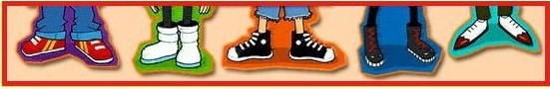

Annual General Meeting

Present
Louise reecejones vanessa hughes
Laura doughty Anne Gay
Hannah brannagan Pam Williams
Bev Bray Kathy Hope

Roles voted in
Chairperson nominated by laura doughty seconded by hannah brannagan, louise reecejones accepted the position
Vice chairperson nominated by LouiseReecejones seconded by Bev Bray, Laura doughty accepted the position
Treasurer nominated by Vanessa Hughes seconded by Louise Reecejones, Anne Gay accepted the position
Secretary nominated by Hannah Brannagan seconded by Pam Williams, Vanessa Hughes accepted the position

Bank account
We will be setting up a bank account with three signaturies

Money available
We have been given a cheque for £100 from a local buisnessman with the great efforts of Kathy Hope thank you and lets look forward to many more

Our group
We have agreed our group is to cover all disabilities dignosed or undignosed we will be fully inclusive to all members of the community .
We have set our constitution and is available to everyone who wish’s to see it

Our goals
To set up a bank account
To apply for funding
To organise a trip out with our familys

Finally it is just left to say Welcome to Small Steps

